GUIDELINES
- You must use the structure of the present template to prepare your proposal.
- You are kindly requested not to modify or delete any sections (excluding this one, “Guidelines”, which shall be removed before submission), as well as all the parts of instructions written into brackets and in Italics format.
- The maximum total length of sections 1 to 5 of your proposal shall not exceed 12 pages in total, including figures and tables, which are much recommended, with the following page limits for each section:
  - Section 1: Your solution. 3 pages (max)
  - Section 2: Expected Impact. 2 pages (max)
  - Section 3: Work Plan. 3 pages (max)
  - Section 4: Team experience. 2 pages (max)
  - Section 5: Business sustainability 2 page (max)
  - Section 6: Responsible Research and Innovation 2 page (max)
  - Section 7: Ethics 1 page (max)
- Please remember that it is your responsibility to verify that you conform to page limits. Experts will be instructed to disregard any excess pages above the 15-page limit.
- The minimum allowed font size is Arial 10. Please use the same page margins as in this document.

GENERAL INFORMATION
Organization name
National VAT number
website URL
Year of foundation
number of employees
(If applicable)
Turnover of the last fiscal year ended
(If applicable)
Headquarters Country
Subsidiaries countries
CONTACT DETAILS OF THE LEGAL REPRESENTATIVE
First Name
Last name
email
Phone number [e.g. +34 987 654 321]
CONTACT DETAILS OF THE COORDINATING PERSON (IF DIFFERENT FROM THE LEGAL REPR.)
First Name
Last name
email
Phone number [e.g. +34 987 654 321]

PROPOSAL NAME AND ACRONYM of the SOLUTION PROPOSED
[Fill in the name and provide and Acronym if available]
PROJECT SUMMARY
[Maximum 2000 characters – refer to name and acronym as well as publishable summary of the proposed project]
Maturity level of the solution
[Please, indicate the Innovation Maturity Level of your solution according to the table below. You can delete the table once you have completed the answer.]
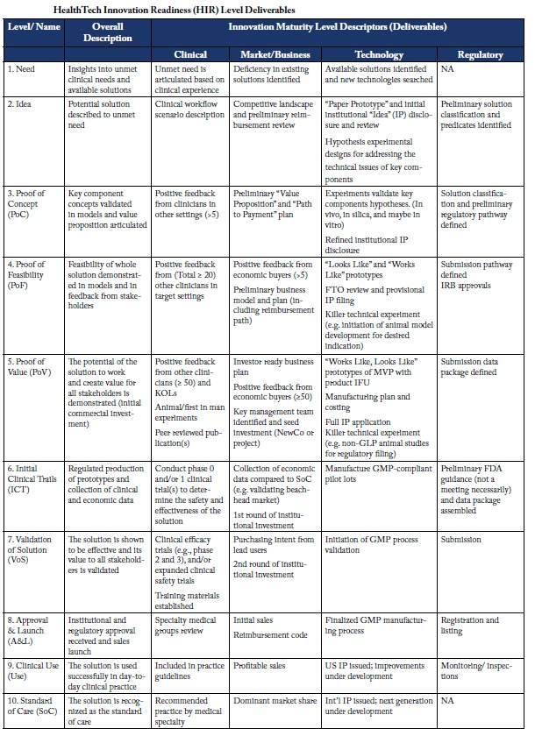
Source: CIMIT

SECTION 1: YOUR SOLUTION

1.1 Solution description
[Describe in detail the overall concept] [Describe its main characteristics and components. Add graphs or mock-ups to illustrate] [Indicate the current stage of development of each key component] [In case of challenges dealing with analytics, indicate here your set up and validation strategy for your algorithm and why you consider your choice of algorithm/model superior to other alternatives]

1.2 Fit with the challenge and compliance
[Give a detailed explanation of how your development fits and solves the challenge: list and confirm it will cover all compulsory requirements and which of the desirable ones. Additional functionality or value should also be proposed here] [Describe how you plan to address compliance with privacy, security and other technical aspects expected during execution]

1.3 Excellence
[Explain what makes your solution excellent and different from your competitors] [List the methodology/es and standards you will use to develop your solution] [Describe how usability and/or end user engagement will be enforced to facilitate their quick adoption]

SECTION 2: EXPECTED IMPACT

2.1 Objectives and success indicator targets
[Describe your objectives and success indicators (KPIs) at the end of the piloting phase, that must include those stated in the call. KPIs should be clear, measurable, realistic and achievable within the duration of the project. State also by what means each KPI will be measured. These KPIs will be scrutinized at the final review of the co-creation phase to assess project success] [Explicit what else (e.g. added value) will be delivered at the end of the pilot]

SECTION 3: WORKPLAN

3.1 Planning of activities
[Provide a work plan describing your planned key activities within the pilot lifetime. This shall include a timeframe in a Gantt chart with milestones against which progress will be measured.]

3.2 Budget breakdown
[Add a table with your budget] [Indicate if you have any extra sources of funding you plan to leverage to complete any part not funded by CHERRIES]

3.3 Co-creation expectations
[Describe your expectations in the co-creation phase with regards to the interactions with professionals, societal actors and users: indicate the number and purpose of the interactions] [Describe the importance given to the co-creation work (objectives and means employed)] [Describe your technological needs]

SECTION 4: TEAM EXPERIENCE
4.1 Team description
[For each project participant indicate gender, role and provide a short biography relevant to the project execution, identifying those that are going to be directly involved in the implementation.][Indicate who will be the main contact point, and how much knowledge that person has on the language spoken in the Challenger country.][CHERRIES reserves the right to require the implication of the team described here]

SECTION 5: BUSINESS SUSTAINABILITY
* The punctuation obtained in this section will only be taken into account in case of tie between two or more solutions. In that case, the punctuation received in this section will be used as tiebreaker.

5.1 Market description and commercialization strategy
[Explain your view on the expected market at national and international level] [Also analyse competing solutions or alternatives] [Explain your strategy to commercialize your solution after the pilot] [Explain your priority customer types, how to reach them and any potential partnerships]

5.2 Commercialization potential
[Describe your company: experience in the sector and/or in the proposed challenge] [Indicate international subsidiaries, if any] [Describe why your company is better positioned to outperform competitors]

5.3 Business commitment
[Describe why your company is interested in developing a (new) business line around this challenge. Why it is important for you to win this project] [How do you plan to fund future development and commercialization efforts after the piloting]

SECTION 6: EHTICS

6.1 Ethics
[Please, explain whether there are any ethical issues to be considered in your proposal. Please see H2020 rule regarding ethics. If your solution foreseen the gathering, the storage and the management of open (health/patient/users) data, do you see sensitive/ethical issues which might hinder the adoption of the solution? Do you see any other ethical/controversial issue which might impact negatively on the societal adoption of the solution? If yes, how do you plan to tackle this issue during the implementation of the pilot? Has your company/organisation an ethical Code of conduct concerning the respect of principles and standards for the research (and Innovation) integrity?]

SECTION 7: RESPONSIBLE RESEARCH AND INNOVATION

The punctuation obtained in this section will only be taken into account in case two or more solutions get the same score. In that case, the punctuation received in this section will be used as tiebreaker.

7.1 Gender Issues
[Three objectives underpin the strategy on gender equality in Horizon 2020: 1) Fostering gender balance in research teams, in order to close the gaps in the participation of women. 2) Ensuring gender balance in decision-making, in order to reach the target of 40% of the under-represented sex in panels and groups and of 50% in advisory groups. 3) Integrating the gender dimension in research and innovation (R&I) content, helps improve the scientific quality and societal relevance of the produced knowledge, technology and/or innovation. Has your company/organisation a GEP (Gender Action Plan) aimed at removing barriers that prevent women take part in scientific careers paths an in the company decision-making? Do you have any Gender Equality policy or any measure in place to address Gender equality (Code of Conduct, Human resources policy, work-family conciliation services, training/mentoring programs, quotas for Gender balance in leadership position, Gender/diversity indicators, etc.). If yes, please provide a summary of the main measures in place. If not, is your organisation planning to set in place some gender equality measures, policies or services for remove eventual barriers (if existing within your organisation)or to develop a specific gender Action Plan in the short term?]

7.2 Public Engagement
[Public engagement (PE) in Responsible Research and Innovation (RRI) is about co-creating the future with citizens and civil society organisations, and also bringing on board the widest possible diversity of actors that would not normally interact with each other, on matters of science and technology. Does your solution contribute to Public Engagement? If so, please explain how.]

7.3 Open science / Open Access
[It is now widely recognised that making research results more accessible to all contributes to better and more efficient science, and to innovation in the public and private sectors. Open access to scientific information in research and innovation refers to 2 main categories: 1) peer-reviewed scientific publications (primarily research articles published in academic journals) 2) scientific research data: data underlying publications and/or other data (such as curated but unpublished datasets or raw data). Does your solution contribute to Open Science? If so, please explain how. Regarding to open Accesss: Are you planning to increase the scientific impact of the results of the Cherries solution to society ¿ If yes, how (open access publications, etc,)]

7.4 Science Education
[Building capacities and developing innovative ways of connecting science to society is a priority under Horizon 2020. This will help to make science more attractive to young people, increase society's appetite for innovation, and open up further research and innovation activities. Does your solution contribute to Science Education or to make science more attractive to young people? If so, please explain how.]

7.5 Governance
[Governance of RRI is any form of coordination designed to foster and mainstream Responsible Research and Innovation within an organisation or in the interaction with other stakeholders. Will your development foster Corporate Social Responsibility? Or foster RRI in your organisation or in the interaction with other stakeholders? If so, please explain how.]

If you are not taxed and don’t have a VAT number, provide the unique identifying number of your company available in your country

