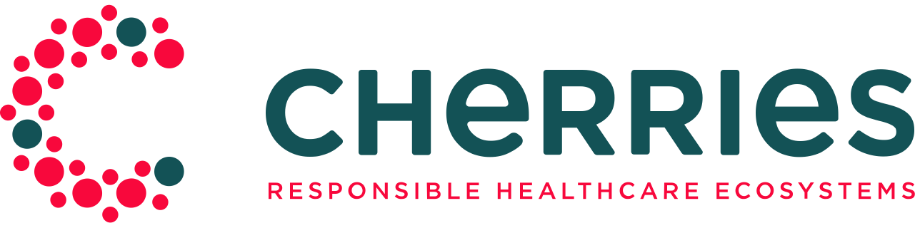

Mirror regions questionnaire for participants
—
September 6th, 2021
Authors: Ulises Pisano, Myriam Martín (Ticbiomed)

CHERRIES Mirror Regions – Application Form
CHERRIES project is looking for 3 Mirror regions interested in replicating project’s model for RRI demand-driven innovations in the healthcare sector and beyond.
Interested regions should submit their application forming a Consortium integrated by at least two organisations –public and private entities—. The consortium should replicate the same constellation of stakeholders defined in the CHERRIES model, considering that the consortium should be able a) to identify need in a concrete sector with the involvement of the civil society; b) to allocate the regional funding to work on the action and c) to support the cocreation process between solution providers – companies selected to develop the solution- and the organisations identifying the need.
The call for Mirror Regions to become member of the community will remain open to receive more committed parties, but only these 3 chosen regions will benefit from a closer mentoring and a tailored support throughout the project's life cycle.
Please fill in the following short questionnaire before November 12th , 2021.

- Name of the Region
- Country

Main contact details of the lead organisation.
Provide the main contact details of the lead organisation.
- First name
- Last name
- Organisation name
- Job title
- Email Address
- Telephone (please, include country code)

Description of the regional consortium
Regions should build a Consortium integrated by at least two different organisations –combination of mixed public and/or private entities— to apply to this call. The information of the organisations composing the Consortium should be presented in this section.
If you need to inscribe more than 4 organisations or you need further help, contact us on the next mail address: ulises.pisano@ticbiomed.net

Organisation 1
- Name
- Legal entity type
- Website (English version of available)
- Description

Contact details of the Organisation 1 representative
- First name
- Last name
- Position
- Email address

Organisation 2
- Name
- Legal entity type
- Website (English version of available)
- Description

Contact details of the Organisation 2 representative
- First name
- Last name
- Position
- Email address

Organisation 3
- Name
- Legal entity type
- Website (English version of available)
- Description

Contact details of the Organisation 3 representative
- First name
- Last name
- Position
- E-mail address

Organisation 4
- Name
- Legal entity type
- Website (English version of available)
- Description

Contact details of the Organisation 4 representative
- First name
- Last name
- Position
- E-mail address

Commitment
- Commitment to identify challenges.
- Describe the available innovation funds that could be used with the CHERRIES approach in your region, the date of the calls, etc. Also describe the access of your Region to structural Funds.
- Demonstrate the feasibility to commit public funding to carry out the activities needed to identify and address the challenge (i.e., own resources, regional structural funds, etc.)
- Any other information that proves interest or commitment to implement the CHERRIES model in the short future?

Motivation
- Describe how Smart Specialisation strategy priorities support your participation in CHERRIES
- Previous experience in challenge (need) identification
- Previous experience in RRI policies

Representativity
- Explain relationships or previous collaborations among members. Examples on collaboration are recommended.
- Are there, or would be there, other stakeholders involved? [Letters of Support are welcome]

Regional Impact
- What do you aim to achieve with the Mirror region status? How will you be able to further make use of this experience in your region? What impact do you expect to achieve?

Data protection
We do hereby inform you that the data you have sent us through this electronic form shall be included in the information systems of Ticbiomed, Tecnologías de la Información de la Región de Murcia. That communication shall be used to deal with your request, as well as to send any information which may be of interest to you about our activity. By indicating your data, and pursuant to the stipulations of article 6 of the L.O.P.D., you are granting your clear consent to Ticbiomed, Tecnologías de la Información de la Región de Murcia to process, in compliance with the purposes mentioned in the previous paragraph above, the personal data provided.
Notwithstanding, at any time you may exercise your rights of access, rectification, objection and, where applicable, cancellation, at the address: CEEIM, Campus Universitario de Espinardo, 7, Espinardo, 30100 MURCIA or at the e-mail: lopd@ticbiomed.org
- I do hereby read and accept the data protection policy.
- Other:

Thank you very much!
Please remember that the call closes on the November 12th, 2021., and selected regions will be informed through the contact person identified in this application form.

